Part One: Child Study
Situation
The Learn2 Education Centre (LEC) is an educational charity with one objective; To advance education for the public benefit for disaffected, disengaged and/or vulnerable young people and adults. As part of the provision, a maximum of six learners may attend one day per week to complete sessions in Functional Skills English and Maths, PSHE (Year 9) or Employability (Year 10/11) related units.

The LEC is situated in extended walking distance of a city centre and on number of main bus routes. The LEC has a welcome area with casual seating, a (small!) kitchenette, two delivery rooms and a soft seating room. All areas are designed for six learners to access.

All learners travel independently to our provision and are required to remain onsite throughout the whole day. Learners have access to an outside garden (weather permitting) at break times and Year 9 learners are not permitted to smoke. There are no other learners or visitors on site whilst scheduled groups are in attendance.

Specific to this child study, the identified learner is scheduled to attend The LEC one day per week with five other learners from his setting and year group. Two qualified and experienced teaching staff members co-ordinate delivery and support throughout the day.

“Rob”
As per his pen portrait (Appendix 1: Pen Portrait), “Rob” (name changed to preserve anonymity) turned fourteen in January and is currently in Year 9 following a part-time timetable at the only city-run extended learning centre (locally referred to as a ‘PRU”; pupil referral unit) for Key Stage 3 learners. Rob describes that he enjoyed attending primary school and that it is his goal to be re-integrated into a specific local secondary school, however there are other schools that he would refuse to attend due to other learners that are on roll there. Rob currently has an open CAF (Common Assessment Framework) with an assigned ‘Children and Families First’ keyworker and he has a Special Educational Needs (SEN) status of ‘School Support’.

Upon referral, Rob had a recorded attendance of 65.6% and academic working levels in English and Maths as Entry Level 1 – which we believe to be inaccurate following initial speaking, listening and social communications. Rob may be considered as slightly overweight for his age and size and at times he does make verbal reference to ‘being fat’. However, from our initial observations, we do not perceive his weight to be a leading cause of behaviours that cause concern within an educational setting.

Rob has been selected for this study, as we believe that as a Year 9 learner, he has the social and academic abilities and the personal desire to be successfully re-integrated into a mainstream academic environment, in time for him to complete his Key Stage 4 education. From our acquired knowledge, Rob rarely attends, engages or stays on task within his extended learning setting and he does not attend his other scheduled youth activity provision. Rob currently has a attendance rate of 83% with us and as such we believe that we have an opportunity to support his re-integration through our nurture setting.
Boxall Profile (i)
Rob’s initial Boxall Profile was completed after attending three, complete daylong sessions, as it was intended he had time to settle into the routine, and familiarise himself with the expected standards within our provision and for our team to be able to observe his typical behaviours.

Rob’s initial Boxall Profile (Appendix 4, Pre-Intervention) identified two developmental strands (G, J) that he was perceived as least competently functioning in, followed by two (A, H) he was not quite competently functioning in. The categorisation for these being (G, J) displaying as -4 and -3 below the indicator scores and (A, H) displaying as -1 and 0 in comparison with the indicator scores. According to the pre-intervention profile results, Rob was completely functioning in six of the developmental strands (B, C, D, E and F, I).

Rob’s diagnostic profile highlighted two areas (T, W) as Rob least competently functioning in with respective scores of +11 and +10. Four strands displayed as more competently functioning; Q = +6, R = +7, X = +6, Y = +5. Rob only had one diagnostic score (Z) displaying as competently functioning.

Observation (i)
Conduct and Emotional behaviours were observed in informal situations and recorded using a scoring table (SNIP, 2007) devised to relate to a learner’s emotional, behavioural and developmental attainments. In the conduct category, Rob was observed to score 36% in the ‘maintains appropriate relationships with pupils’ and 37% in ‘only interrupts and seeks attention appropriately’. The remaining three categories recorded scores a minimum of 50%.

In the emotional category, observations in both the ‘confident’ ‘emotionally stable’ categories scored 33% as opposed to the remaining three categories that scored a minimum of 53%.

Observation (ii)
Learning and Emotional behaviours were observed on the same day, in formal learning sessions using the same scoring tables (SNIP, 2007). In the learning category, seven of the thirty-two (21%, approximately one fifth) of the observations were scored as ‘1, not at all’. Three of the categories, ‘attentive and has an interest in school’, ‘has good learning organisation’, ‘seeks help when necessary’ scored 33% or below compared to the remaining two categories which scored a minimum of 50%.

In the emotional category, observations in the both the ‘has empathy’ and ‘is socially aware’ categories scored 36%, the three remaining categories showed scores of minimum 47%.

Pre-Intervention Analysis of the Boxall Profile
According to Nurture Group Network (2015, p.22), in the developmental strands, A-E are the “most basic skills… that need to be dealt with first… F-J are the next areas to develop”. Within these highlighted strands, Rob identified as least competently functioning in G (biddable and accepts constraints) and J (maintains internalised standards). Strands A and H of the same ilk scored as nearly competently functioning.

Rob’s diagnostic profile showed T (shows inconsequential behaviour) and W (has undeveloped/insecure sense of self) as significantly least competently functioning compared to the other diagnostic profile scores. Q, R, X and Y were scored as (less-significantly) not competently functioning.

Interpreting the scores further, Nurture Group Network (2015, p.22) describes how both sectional scores should be considered together and that particular relationships may be identified between G & T, A & Q. In addition, for Q & R that “until these improve you will make limited progress”.

With G, J, T, W scoring as the least competently functioning and G & T relating to each other, I have analysed these in further detail with reference to Rob:

G – Rob appears to find it difficult to ignore external stimuli, to follow requests and refocus on new instructions. Rob will refuse to work/engage and will actively seek to disrupt others, make inappropriate comments/actions, rather than provide the requested attention.
J – Rob disregards reasoned requests to complete a task, including when it will benefit him individually. Rob will generally find or create more personally appealing distractions and seek to maintain some form of self-created bravado.
T – Rob appears impulse driven and displays behaviour seeking to impress peers or make others perceive that he is more interesting/daring/courageous than perhaps he is. Rob regularly uses inappropriate language and describes scenarios which appear to place him in the role of an older and more ‘streetwise gangster’ and sexually active young man. Rob appears to seek reaction including plaudits from his peers.
W – Rob seeks positive responses to his stories, comments, actions in front of others. Rob seeks acceptance of the character he is portraying. To adults, he often discloses conversations he has had with Mum, suggesting a nurturing home relationships and compliancy and healthy adult interactions. Rob seeks attention by his actions and his methods of communication.

With more intervention, I may choose to further analyse Q & R as priorities.

Pre-Intervention Analysis of the Observations
The yellow sections of the both the learning and conduct observations (Appendices 2 and 3) highlight areas that Rob was observed to have lower scores, however, detailed analysis of the observations is not the primary focus of this assignment. A more detailed analysis can be reviewed at Appendix (6a).

Pre-Intervention Interpretation of the Boxall Profile and Observation Analyses
Both the outcomes of the Boxall Profile and two observations appear to indicate that:
- Rob has an on-going desire to be accepted as the person he perceives he wants to be seen as;
- Rob seeks praise/applause/acceptance/awe through his inappropriate and uncontextual actions/comments;
- Rob does not appear to recognise given praise is real/deserved/warranted;
- Rob thrives on positive feedback that is communicated with home (Mum) and school;
- Rob is generally happy and pleasant, non-malicious with good attendance and a desire to attend;
- Rob will quickly change his behaviour according to environmental and peer changes;
- Rob does not appear to have genuine friends within our or the extended learning centre provisions and has a desire to ‘fit in’ with what he may see as desirable traits of other peers;
- Rob is less likely to give up on tasks and more likely to attempt when working in an independent space and without perceived pressure of ‘streetwise’ peers present;
- Rob appears unable to ignore distractions, preferring to want to ‘fit in’;
- Rob is likely to leave a task unfinished deeming it too hard, for bravado or due to distracting/being distracted.

Action Plan
I used my professional judgement, experience, discussions with colleagues and suggested strategies by Rae et al (2013), prior to agreeing the Action Plan (Appendix 5: Action Plan). Appendix (6a) documents potential positive intervention strategies that I shortlisted, in order to progress areas that Rob appears to be less competently functioning in.

Boxall Profile (ii)
In the developmental strands, the score for H remained the same, and strands A, D, E, F and J had increased scores of +1. Strands D, E and F already showed Rob as functioning competently in these areas, however strands A and H now appear to show Rob at the functioning competently level. Strands G and J (the weakest scores from completion of the first Boxall Profile) still show that Rob is not functioning competently in these areas, however he has made progress.

In the diagnostic profile, strands Q, S, Y and Z scored the same and the remainder of the strands, whilst improving by either 1 score (U), 2 scores (R, W, X) or 3 scores (T) did not show Rob to be currently functioning competently in any of the aforementioned areas.

Further observation between the scores is that in the developmental strand, no original scores of 3 or 4 changed in the second profiling exercise, nor did any original scores of 2 or 1 in the diagnostic profile. This could indicate observer bias.

Perceived Impact of Intervention To Date
Rob attended nine day long sessions between the completion of each Boxall Profile, was absent on two occasions and had a Christmas outing/celebration on one other.

Throughout the nurture intervention, positive progression has been observed comparing the two Boxall Profile scores in all four targeted areas: G, J, T, W. Both G and J indicate that in the developmental strands, Rob is now only ‘two scores’ away from functioning competently in both of these areas. Should Rob’s scores increase by two in both, his profile will show him as functioning competently in all of the developmental strands. The second diagnostic profile scores for T and W both showed significant -8 scores for how Rob is perceived to be functioning competently. However, both areas still showed a marked reduction of 11 and 1- respectively.

Comparing the improved scores of the target areas G and J suggests Rob has begun to acknowledge requests to complete tasks and is making efforts to maintain attention through a directed time. The less improved scores of T and W may indicate whilst improvements in his behaviour have been observed, he is still struggling to refrain from inappropriate or out of context comments/actions.

Next Steps to Prepare for Re-Integration
Categories S, Y and Z appeared to make the least improvements. Therefore, if the existing target areas of T and W become the main foci, the aim would be that Rob begins functioning more competently in all five of these, at time of the next review.

We have had conversations surrounding re-integration into mainstream education with Rob and he is aware that he will firstly need to successfully engage with formal learning at the extended learning centre - prior to the end goal becoming a reality. To this end, we aim to celebrate Rob’s progress in remaining more on task, attempting learning activities and being less/causing less distractions in the classroom, with the extended learning centre, in the hope that he mirrors these behaviours there and progresses them even further.

At this point, we would now like to jointly meet with his extended learning team (and possibly Mum) to revise the current action plan and agreed a joint one, developing from the successes we have seen and the strategies we have used to date.

Part Two: Reflection
The Foundation Stage
In 2007, I founded my organisation, Learn2 to deliver alternative curricula programmes within schools after I had become frustrated by experiences I had repeatedly witnessed within local secondary schools. I formed an opinion that learners classified as at ‘high risk of becoming NEET’ (not in education, employment or training), were often sent to sit/wait in corridors for senior members of staff and excluded from classroom learning experiences; generally due to continual low levels of disruptive behaviour. It was (and still is) my belief, that with the optimum caring and a structured learning environment, disaffected and disengaged learners are able to thrive within (adapted) classroom environments.

In 2012, I self-funded and opened The LEC, Learn2 Education Centre, for learners to attend 0.5/1 day per week provision, in small group sizes. The LEC was successful in recruiting Year 10 and 11 learners from local secondary schools and the county referral unit from its first day of opening. I was very conscious that I wanted the provision to be taken seriously in the eyes of the schools and not to be seen as some sort of youth activity base, so, I ensured that The LEC was operated similarly to a school. To this end, I ensured that all staff held formal teaching qualifications.

I designed and opened The LEC prior to having any awareness of the widely accepted term ‘nurture groups’. Nurture groups being a concept developed at the end of the 1960s in East London (UK) by a school psychologist, Marjorie Boxall and her team. Boxall (2002) cited by Couture (2012, p.265) reported that as early as the 1960s, many violent, aggressive and disruptive children were referred to clinics and several children were excluded from school a few weeks after their entry. To this end, I am surprised in the fifty years of growth and development of formal nurture provision such as accredited nurture groups (Nurture Group Network), that recognised and formalised nurture group provisions appear to be most prevalent in primary schools and smaller special educational needs (SEN) provisions within secondary schools, as opposed to within referral and exclusion provisions, such as is the main referral pathway of learners accessing The LEC.

In 2011, Ofsted completed a survey of 29 infant, first and primary schools, examining the use of nurture groups. The only referenced sources related to the term ‘nurture group’ were Marjorie Boxall and the Nurture Group Network. Ofsted (2011), described how the surveyed schools “sought to provide a safe, comfortable, home-like environment, with clear routines and adults modelling positive relationships, in line with nurture group principles”. Ofsted reported that sometimes the pupils who were selected for the groups had been previously excluded from school on a fixed-term basis, were in danger of permanent exclusion, or were being considered for a move to special school.

Furnace (2014, p3), described how Boxall drew on the principles of attachment theory when developing the nurture group approach. Furnace further described how according to Bowlby (1969), difficult behaviour in school was the result of poor or faulty attachments. Boxall (2002) cited by Furnace (2014, p4) outlined “the primary function of a nurture group therefore, as to create the opportunity for children who have missed out on these crucial early experiences to ‘start again’, be nurtured and re-experience early attachment in school”.

Colley (2011, p4) evaluated a range of developmental theories in a bid to understand the concepts associated with nurture group intervention. Marjorie Boxall, a pivotal figure in founding the diagnostic tool, Boxall Profile and documented in numerous sources as founding and developing nurture groups, associated closely with Attachment Theory. Colley further commented on social cognitive theory and on the works of Piaget, Vygotsky and Maslow, whom, he claimed “approached childhood understanding as part of a development process rather than focusing on needs of students with social, emotional and behavioural difficulties”.

Copper and Whitbread (2007); Kearney (2005), both cited by Colley (2011) stated that Maslow’s (1954) theory related to human motivation influenced nurture group practice. Maslow formulated five hierarchical levels of basic human needs, with each prior stage being required to be completed before progress could be made; physiological (biological needs for oxygen/food/water/body temperature), safety (feeling safe and secure), social (love, affection, belonging), esteem (self-esteem, self respect and both from others), self-actualisation (feeling they have ‘made it’).

In 2012, having no knowledge or experience with the concept of formal nurture groups, I consciously designed The LEC provision and functionality around Maslow’s Hierarchy of Needs. I translated Maslow’s concept in numerous ways:
- learners feel as though their food, thirst and basic clothing/warmth and safety needs are met, by being greeted on arrival with bright and welcoming colours, comfortable ‘homely’ furniture and the offer of ‘tea and toast’ time;
- learners feel protected and supported by receiving tuition in maximum group sizes of 5, with session times and content clearly labelled and described through the day;
- learners feel as though they belong by being able move freely throughout the space and sharing in making and clearing a ‘unit style’ meal at lunchtime
- learners esteem is raised as through attendance and engagement they begin to achieve academically, via certificated courses and social, emotionally through receipt of positive communications with home and awarding of ‘credits’
- the end goal we have for all learners is that they positively progress (self-actualise) by re-integrating into their formal educational provision, or to further education, training or work.

Post Accredited Nurture Group Training
In 2015, I moved The LEC premises and provision from our larger and more spacious provision to a smaller ‘three-bedroom flat with backyard’ type of premises, in order to make vast financial savings per year. This inevitably meant that I had to make some changes on how our nurturing provision continued and I feared that I may have to lose some of the ‘Maslow-based foundations’ that I had previously embedded, with such positively observed effects.

Concurrently, I attended accredited nurture group training which enabled me to compare and contrast both my previous and current locations and create an action plan to develop The LEC more aligned to recommended nurture group practices. Following my nurture group training, I made the following changes to The (new) LEC:
- I changed a sliding door to a fixed opening and closing to improve acoustics and ‘close/open’ the room
- I had the back garden aesthetically fenced with secure gates fitted
- I added a double swing set and boxing bag with gloves to the back garden
- I added automatic lights to the alleyway entrance
- I added an aesthetic storage unit inside the entrance to cover an old stairway to seem more welcoming
- I bought a halogen tabletop oven so that we could still make pizzas
- I changed our smallest room from a class seating arrangement to soft-seated breakout area

The accredited nurture group training introduced me to a whole new concept of ‘Boxall Profiling’ (See Section 1). Prior to attending this training, I would recognise all of our learners as having generic behavioural and educational specific and additional needs, however as a provision we had no formal method of assessing their social, emotional and behavioural difficulties, with no structured recommended intervention or progression measures. Since attending training, we have introduced completing an initial Boxall Profile assessment on the learner’s third week of attendance. We compare our outcomes with those of a Boxall Profile completed by the learner’s home school and of their risk assessment, including positive behaviour management strategies and any additional information such as Professional’s reports. This enables us to create individual learner targets, which we can then discuss with the learner and school, agree and review at half termly intervals. I am of the opinion that introducing this process has provided more opportunities for focused discussion around behaviours and instilled a confidence in the delivery team members in suggesting and monitoring positive intervention strategies.

Through attending the accredited nurture group training, I recognised that The LEC I set up in 2012 aligned very closely to the definition of a ‘new variant’ type of Nurture Group setting. Couture (2012) described a number of researched nurture group models including new, classic and aberrant, all with different variants; “adhering to the important principles of the classic model, but differs in structure and/or organisational features”. The Nurture Group Network (2015) recognises ‘Classic Boxall’ as the model for a nurture group to gain accreditation. One significant feature of this being that learners attend 80% of their academic timetable (four days per week), prior to being re-integrated into their mainstream provision. In a new variant model learners may attend nurture provision between half and four days per week.

Cooper and Whitebread (2007) propose that only the ‘Classic’ and ‘New Variant’ approaches can be seen as genuine Nurture Groups. In contrast, ‘Groups Informed by Nurture Group Principles’ are said to “provide emotional support as opposed to focused intervention and ‘Aberrant’ groups could be considered as a potentially dangerous model promoting a distorted image of the original approach”. Furness (2014, p4)

Perceived Challenges in Delivering as an Accredited Nurture Group
A primary concern is that The LEC is not recognised formally as a nurture provision as learners typically only attend for one day per week in contrast to recommendations that learners attend four days per week. In response to this potential criticism, I would argue that our learners attend on a weekly basis throughout an entire academic year, which, can be more beneficial for a 14-16 year old learner that will progress into a community learning environment, rather than a protected school setting. Our learners travel independently to our provision, by repeatedly attending our highly structured provision, our learners benefit equally to those as per a more traditional nurture offer.

A further developed criticism to the former could be, that as learners intentionally attend our provision for a complete academic year, we are not attempting to re-integrate them as per Classic Boxall recommendations. Boxall 2002, p.214) makes no reference to re-integration to other environments, other than to a mainstream class in nursery, primary (or assumed secondary) school. This would suggest that nurture environments for learners excluded from their mainstream provision that follow part-time timetables with embedded alternative provisions and are reaching the end of their mandatory schooling, are not catered for in current accredited nurture group standards.

In response, I would argue that we, as educators, have a duty to prepare our learners for entering positive progression routes that are within their community and external to a school setting as more traditionally seen in a nurture group setting. As such, I would argue that the more our learners can independently and routinely attend structured provision outside of their home school, the more we are likely to increase their success in attending a positive progression where there is significantly less nurturing support. Seal and Harris (2016, p.230) described a young person’s bond to the community of society as essential to their development. Harris continued to describe Hirschi’s 1969 theory associated to social ties. He commented that when observed, “participant’s in his study changed their behaviours upon being removed from school, including changing their peers”. If we can therefore provide an extended and consistent nurture opportunity where learners mix with peers outside of their home location, we may facilitate a more sociable and less stressful positive progression into Post 16 provisions.

Post Accredited Nurture Group Training
Whilst I am encouraged by modifications I have made to The LEC since attending the training, I still have an aim to receive a Nurture Groups Network ‘Quality Mark Award’ and acknowledge that I have challenges to overcome in order for an application to be considered:
- our learners attend for one day per week throughout an academic year, as opposed to four;
- we would need to ensure that we have clearly publicised policies detailing how nurture provision is our core delivery mechanism and show how our referral partners understand and acknowledge this offering;
- we would need to consider how we would share information about our nurture provision with parent/carers;
- we would benefit from my primary associate team attending a formal training course;
- we may need to consider how we could encourage more frequent visits and interactions from the learner’s home school link;
- we may need to consider further formalising the review of Boxall Profile scores and filing more detailed action points within minutes;
- we may need to agree with referrers how we can measure the impact of our formal nurture provision upon their re-integration, or, positive progression;
- we would need to discuss and agree what parental engagement would/could/should look like in our setting.

Part Three: Appendices
Appendix 1: Pen Portrait
Rob attends the city council’s extended learning centre for Key Stage 3 learners, since being permanently excluded from his secondary school. Rob attends our provision one day per week and is timetabled to attend another youth activity provision one day per week alongside his extended learning centre for two mornings. Rob has voluntarily discussed with us that it is his goal to be re-integrated permanently into mainstream school, however he struggles to fully and appropriately engage at the extended learning centre. Rob has both commented and agreed on how his home (Mum) and school receiving positive feedback about his engagement in our provision will likely support his end goal, however he will still not attend, due to other learners on roll, the other youth provision.

Rob is generically a polite young man who regularly demonstrates that he understands manners and knows appropriate, accepted language and behaviours for given situations. Examples include his use of greetings, automated making and clearing of drinks, following of instructions/acknowledgement of warnings when he chooses. However, Rob regularly displays inappropriate, silly, immature, out of context language and behaviours, which appears to be seek attention and accolade from peers that he feel are ‘higher’ in terms of social circle or more ‘streetwise’/rogue. When working within a very small group, with peer(s) he may see as more ‘equal’ to him, Rob can fully complete academic tasks to a high standard. With other peers present, Rob appears to struggle to concentrate, start and remain on task - even when he is capable of completing the work and his peers are fully on task.

Rob’s referral form records that he has a ‘CAF’ in place and is classified as ‘School Support’. It also records he receives TA support in lessons. ‘Silly’ behaviour is the only recorded trigger.
Rob’s risk assessment categorises him as ‘medium risk’, referred to the extended learning centre due to behaviour issues in mainstream school. Rob’s risk assessment states that he ‘frequently accidentally bullies’, which may be in a racist manner. Rob is rarely absent and his displayed behaviours are believed to be learned and connected with educational difficulties. Trigger points on the risk assessment are recorded as family, control and environmental issues with types of typical observed behaviours (with anybody) including being immature, disruptive, running around, encouraging others to misbehave and silliness in classrooms and corridors.

Positive behaviour management strategies are recorded as working1-2-1, planned withdrawal to/working in a quiet room, specific seating arrangements, positive phone calls and positive postcards home.

Summary of strengths;  - regular and punctual attendance  - awareness and ability to behave age appropriately  - ability to complete set tasks  - desire to re-integrate into full-time education  - positive and communicative relationship with home | Summary difficulties;  - appropriate behaviour in group situations  - repeated inappropriate comments for reaction/ acceptance (often of out of context sexual nature)  - reluctance to be seen by peers as working/on task  - refusal to complete set tasks, distraction of peers

Plan what you need to observe and the best way of doing so.
What are you going to observe? | How will you record these observations?
Conduct Behaviour and Emotional Behaviour  This observation will take place during out non-academic/non-learning situations such as on arrival during ‘tea and toast’, break, lunchtime and the plenary activities at the end of the day. | The Welsh Assembly Government (2010) published a web link to a free resource published by The Special Needs Information Press (SNIP, 2007) that provides a scoring table to record observations related to a learner’s emotional, behavioural and developmental attainments.  Observations will therefore be recorded as per the scores on the template, with a written interpretation summary following.
Learning Behaviour and Emotional Behaviour

This observation will take place following delivery of the academic/learning sessions of English, Maths and the current Healthy Living unit.
-----------------------------------------------------------------------
Emotional behaviour will be recorded during both observations with a view to have a constant baseline score for comparison.
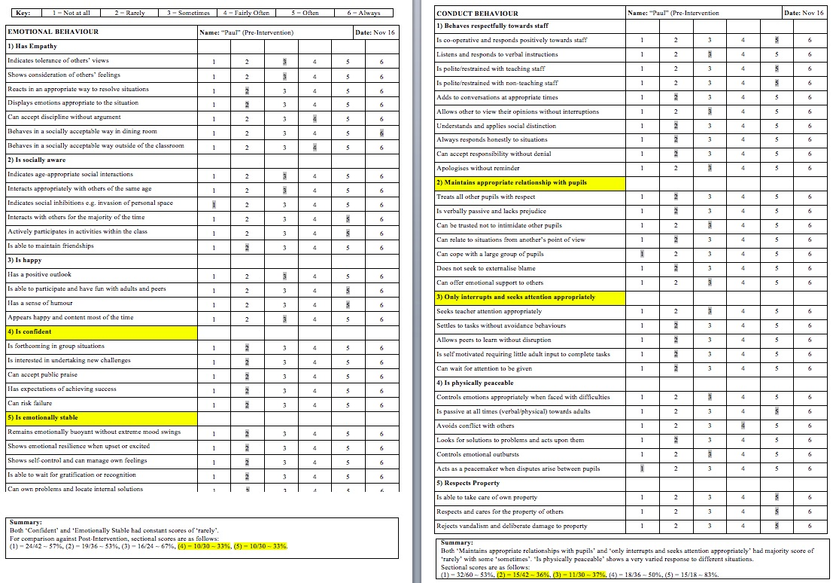
Appendix 3: Observation Two, Classroom

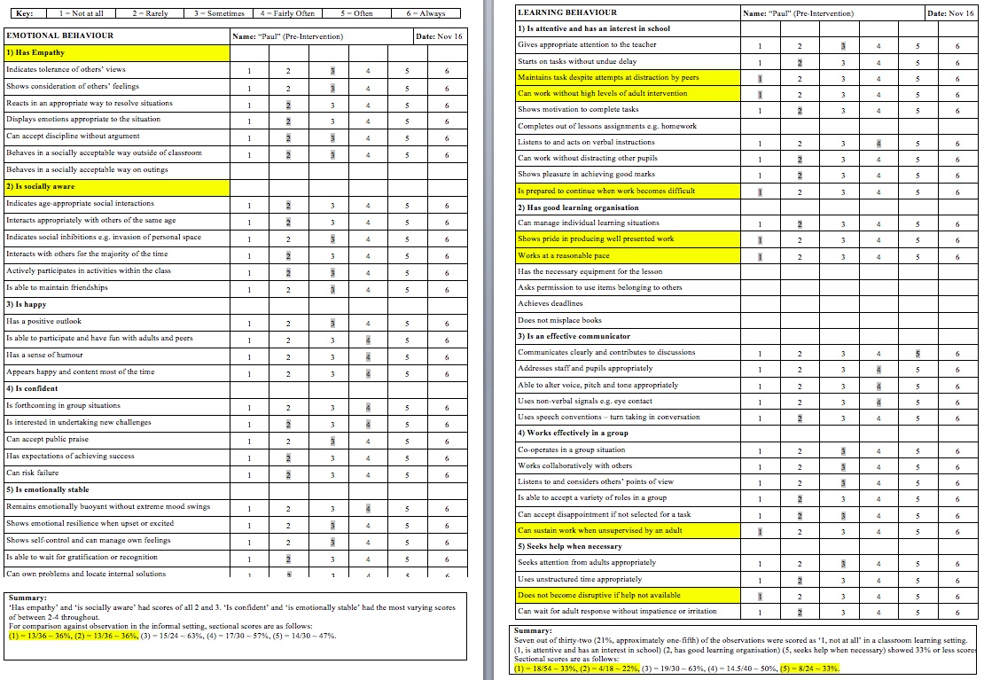

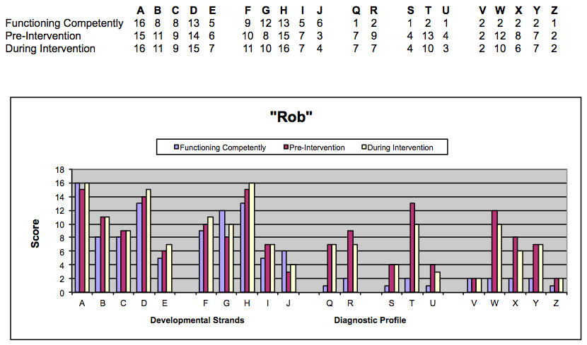
Appendix 4: Boxall Profile Pre-Intervention and Post

Appendix 5: Action Plan
Nurture Group – Target Setting
Learner Name:  “Rob” | DOB:  Aged 14, Year 9 | School:  The LEC | Start Date:  November 2016 | Review Date:  March 2017
Overall Target: To re-integrate into mainstream provision
Identified difficulties | Targets to be achieved | Activities, Strategies & Resources | Measured by…  (Success criteria / positive targets) | Results/Outcomes
Striving to be accepted as the person he perceives as wanting to be.  Displaying inappropriate behaviours, staying off task. | (1) Only speak the truth  (2) Aim to act maturely, with acceptable topics of conversation | (1) Respond to prompt/game “Fact of Fiction” and ‘answer’ with eye contact  (2) Immediately stop conversation when word “inappropriate” is spoken by any of the team | (1) Reduced observations of inappropriate behaviours/ actions  (2) Conversations stopped/ immediately changed upon hearing word | ‘Credits’ awarded for positive responses  (a) texts and (b) phone calls are made per agreed number of credits earned
Lack of aspirations and belief in own abilities.  Not attempting, or not completing tasks. | (1) Complete all set tasks  (2) Stay on requested task for the allocated time | (1) Ask for your work to be marked immediately upon completion!  (2) Use/request the sand timer as a visual guide for how long you need to stay focused and undistracted by | (1) Set tasks are completed in folder  (2) Engagement remains throughout duration of sand timer | Recognition is made on portfolio work, work shared with school and with home  ‘Credits’ awarded for both remaining on task throughout the sand timer and completing the task
Changing displayed behaviours according to environmental or persons. | (1) Refrain from inappropriate comments/actions  (2) Work/act consistently, whoever is present | (1) Immediately stop conversation when word “inappropriate” is spoken by any of the team  (2) Complete all set tasks as per your previous target | (1) Conversations stopped/ immediately changed upon hearing word  (2) Set tasks are completed in folder | (a) texts and (b) phone calls are made per agreed number of credits earned  As per second target, in addition, reflection meeting at school and additionally at home to recognise positives and progression

Appendix 6: Additional Evidence
6a) Pre-Intervention Analysis of the Observations
Within informal settings, Rob appears to regularly display inappropriate and socially unacceptable behaviours, however these are generally positively adapted when he enters formal learning environments suggesting that he understands and accepts requirements. However, inappropriate and uncontextual behaviours are still regularly and spontaneously observed.

Informally, Rob is observed to chat at ease with adults, happily use his phone independently, or to recall/brag about inappropriate or unlikely stories to his peers. Within classroom group settings, Rob displays no issues with being placed in groups, however he does not complete assigned tasks (either independently or as a group member) and does not appear to categorise his peers as his friends.

Rob generally appears a happy person with a sense of humour and positive outlook in both settings.

Whilst socialising informally, Rob does not appear to expect to receive praise, or feel that it is real or warranted when directed at him. Similarly in a task and learning environment, Rob has been observed to participate to a degree, but take no pride in the end product or have no expectation that he can do it well. Contrary to observations in both settings, we have experience that Rob thrives on his home (Mum) and his school receiving positive feedback about his performance.

Overall, the observation scores in the informal setting were lowest (36%) in the ‘empathy’ and ‘socially aware’ categories, compared to 57% and 53% respectively in the learning setting. In the learning setting, observation scores were lowest (33%) in the ‘confident’ and ‘emotionally stable’ categories, compared to 57% and 47% respectively in the informal setting. The difference in scores in the emotional category may indicate that Rob’s emotional state does change when he enters different environments and settings.

The yellow sections of the both the learning and conduct observations (Appendices 2 and 3) highlight areas that Rob was observed to have lower scores, however, detailed analysis of the observations is not the primary focus of this assignment.

6b) Action Plan
Using my professional judgement, experience, discussions with colleagues and suggested strategies by Rae et al (2013), prior to agreeing the Action Plan (Appendix 5: Action Plan), I have shortlisted potential positive intervention strategies in order to progress areas that Rob appears to be less competently functioning in:
Area | Potential Strategies
Striving to be accepted as the person he perceives as wanting to be.  Displaying inappropriate behaviours, staying off task | - Clearly listing, specific, inappropriate words/phrases/actions and associated internal consequences  - Use of ‘code’/discreet word/action between team and Rob, that peers do not recognise or acknowledge  - Tactically ignore observed inappropriate behaviour
Lack of aspirations and belief in own abilities.  Not attempting, or not completing tasks | - Set specific tasks as group around table before moving them to individual spaces facing the wall, then bring back in, etc.  - Deliver sessions in different rooms differentiated by academic levels  - Use personal sand timer to indicate minimal time to stay on task/not receive attention/before being brought back in whatever progress has been made (i.e. not mandatory that the task has been finished)  - Mark immediately and give visual and verbal effort and attainment score  - Use only very specific and directed praise and relate positively to expectations  - Engage with throughout set task
Changing displayed behaviours according to environmental or persons | - Be extremely explicit about expectations, with tangible rewards  - Ensure the day template is visible and used correctly as day progresses  - Ensure environments are routinely changed/rotated throughout each activity  - Provide an outlet for non-adult guided time at lunch  - 1-2-1 to conclude if met targets/agreement(s) at the end of each day  - Reflect with learner and home, school at respective premises focusing on positives

Bibliography

Boxall, M., 2002. Nurture Groups in School. Principles and Practice, London: Paul Chapman Publishing

Cole, T., 2015. Mental Health Difficulties and Children at Risk of Exclusion from Schools in England. A review from an educational perspective of policy, practice and research, 1997 to 2015, University of Oxford: Emmanouil Agianniotakis

Cole, T., Daniels, H., Visser, J., 2012. The Routledge Companion to Emotional and Behavioural Difficulties, Oxon: Routledge

Couture, C (p264-271). The Value of Nurture Groups in Addressing Emotional and Behavioural Difficulties and Promoting School Inclusion

Colley, D., 2011. The Development of Nurture Groups in Secondary Schools, University of Leicester (unpublished)

Furness, A., 2014. An Exploration of Nurture Groups in Secondary Schools: How they are working in one large shire county in the South-East of England, University of East London (unpublished)

Nurture Groups Network, 2015. The Theory and Practice of Nurture Groups, London: Nurture Groups Network

Ofsted, 2011. Supporting Children with Challenging Behaviour through a Nurture Group Approach, London: Crown Copyright

Rae, T., Colley, D., Roden, W. and Stollery, H., 2013. Beyond the Boxall Profile for Young People. Strategies and Resources, The Nurture Group Network.

Seal, M., Harris, P., 2016. Responding to Youth Violence Through Youth Work, Bristol: Policy Press

Special Needs Information Press (SNIP), 2007. Behaviour Audit,
http://www.snip-newsletter.co.uk/pdfs/downloads/behaviour_audit.pdf

Welsh Assembly Government, 2010. Nurture Groups: A handbook for schools, Wales: Crown copyright

